Test Results

Test logs

Test Case: Testing and validating login function

Description: Test the user login for the valid user name and password. The user login should identify the user’s privileges, id and the user’s name. Only the authenticated users who are registered to use the tab application system should be allowed to login.

Test Data: 1. Try to login without credentials

**Expected Output**

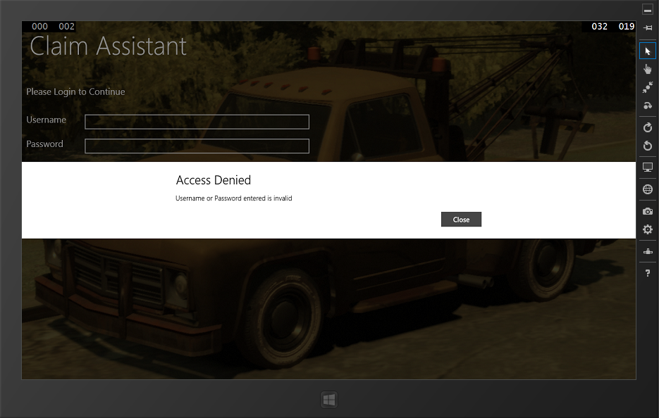

**Test Result**: Successfully received the expected message

2. Try to login with invalid credentials

**Expected Output**

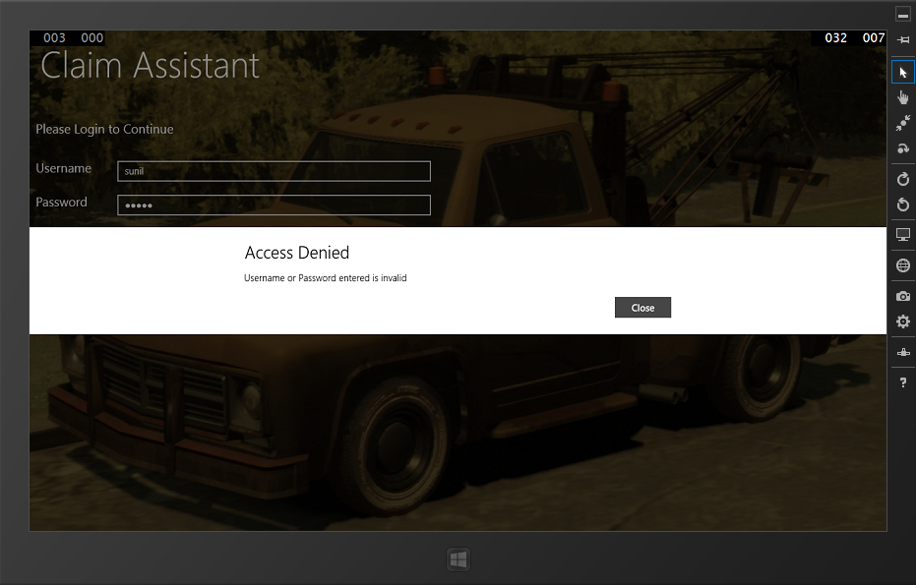

**Test Result**: Successfully received the expected message

3. Try to login when network unavailable

**Expected Output**

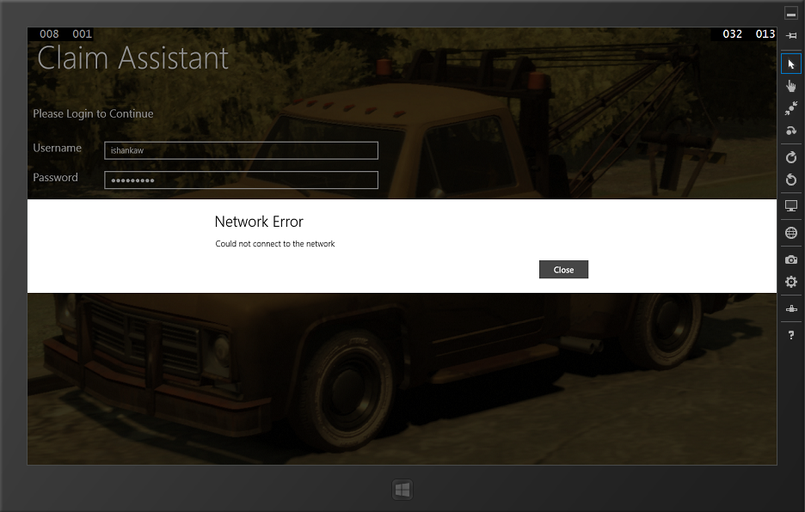

**Test Result**: Successfully received the expected message

3. Try to login when without enough access.

**Expected Output**

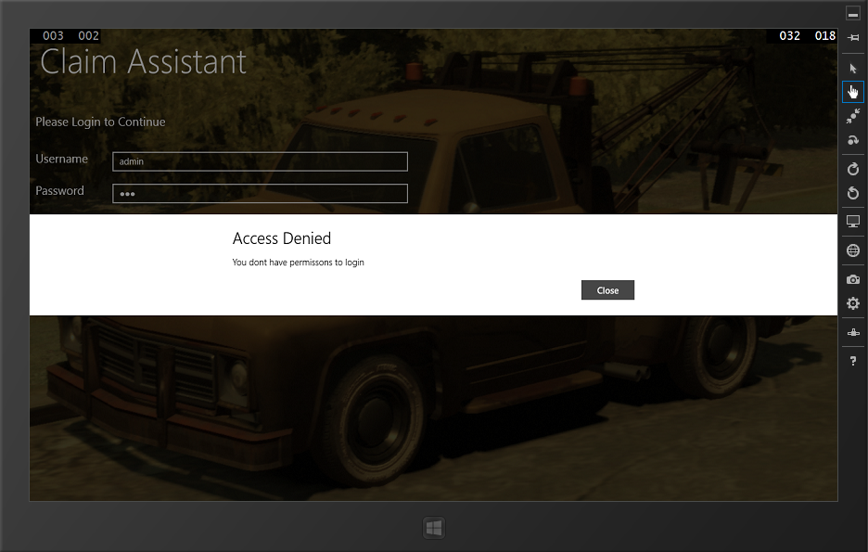

**Test Result**: Successfully received the expected message

4. Try to login with valid credentials

**Expected Output**

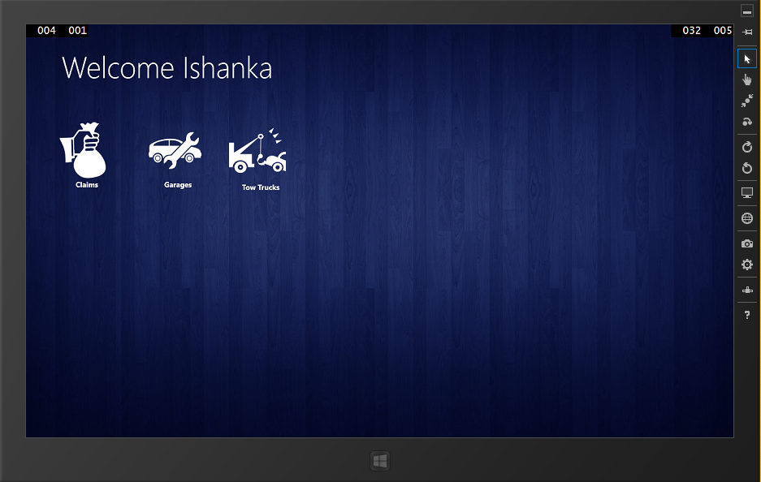

**Test Result**: Successfully received the expected output. User logged in successfully. Next screen displayed.

Test logs

Test Case: Testing and validating Policy information module.

Description: Test whether the system identifies the customer’s policy numbers and allows the agent to retrieve the relevant data of the relevant module from the company database through the web service.

Test Data:

1. Submit without policy number

**Expected Output**

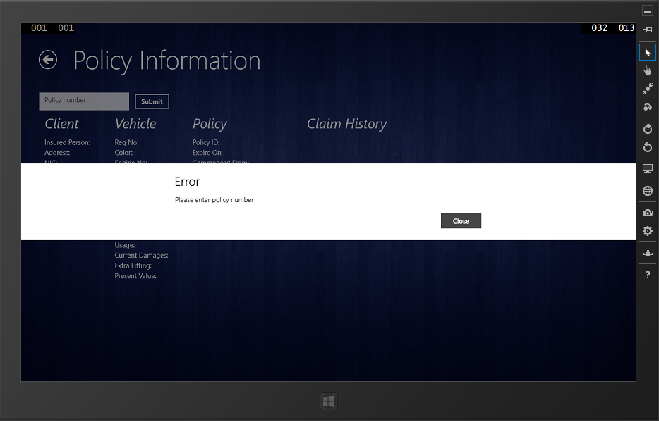

**Test Result**: Successfully received the expected message

2. Submit with invalid policy number

**Expected Output**

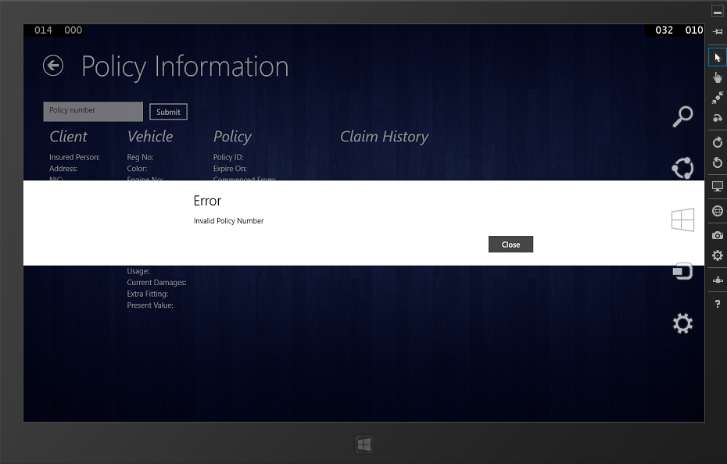

**Test Result**: Successfully received the expected message

3. Submit with valid policy number

**Expected Output**

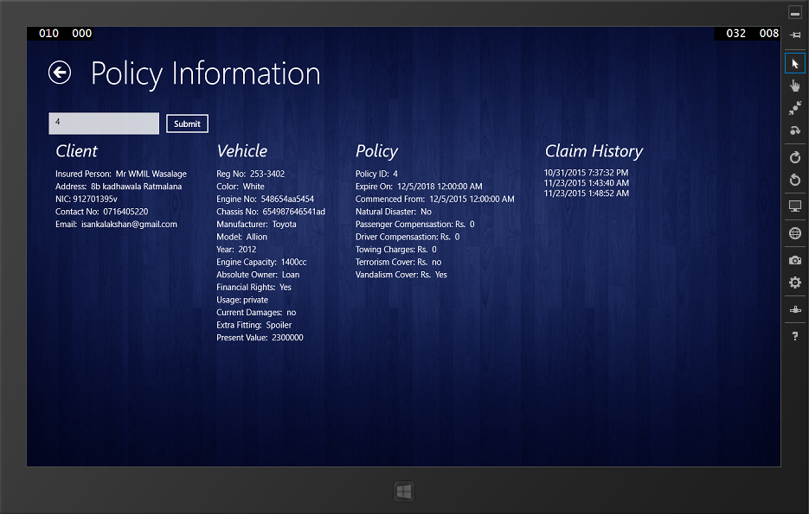

**Test Result**: Successfully received the expected information

Test logs

Test Case: Testing and validating claim assessing

Description: Test whether policy number has being entered before moving to the claim form filling. Then check whether all the required fields are entered. If entered can move to the next screen and finally submit.

Test Data:

1. When agent tries to claim without entering clients policy number

**Expected Output**

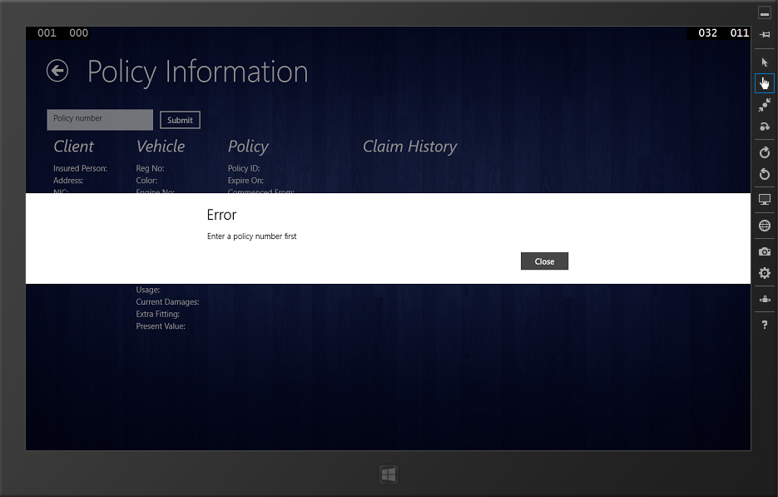

**Test Result**: Successfully received the expected message

1. When user enter policy number then press claim button.

**Expected Output**

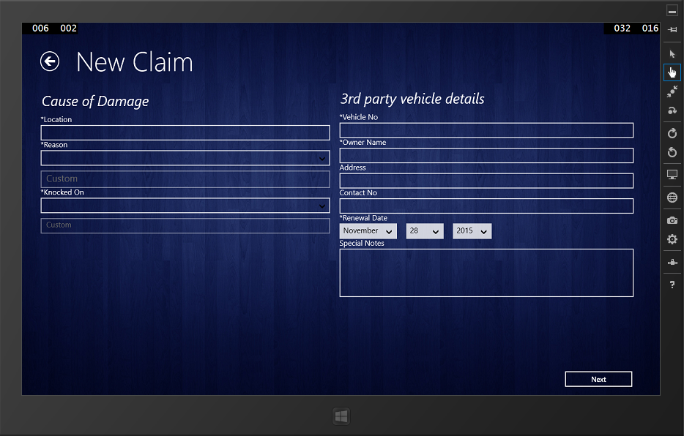

**Test Result**: Successfully received the expected message

1. Checking for required filed in claim form

**Expected Output**

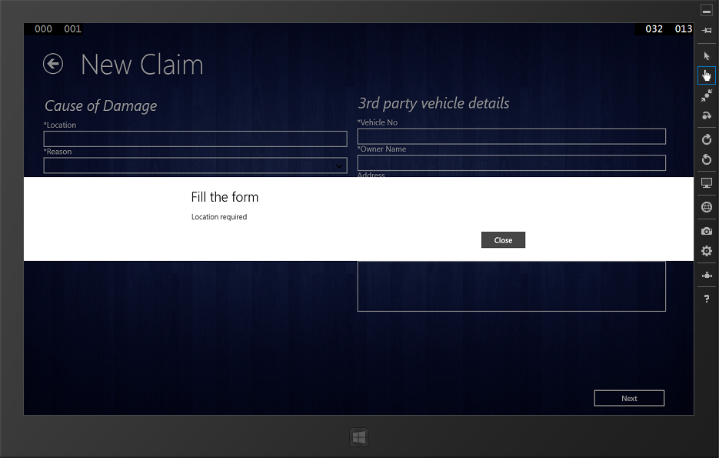

**Test Result**: Successfully received the expected message

1. On successful completion of filling first form and press Next button

**Expected Output**

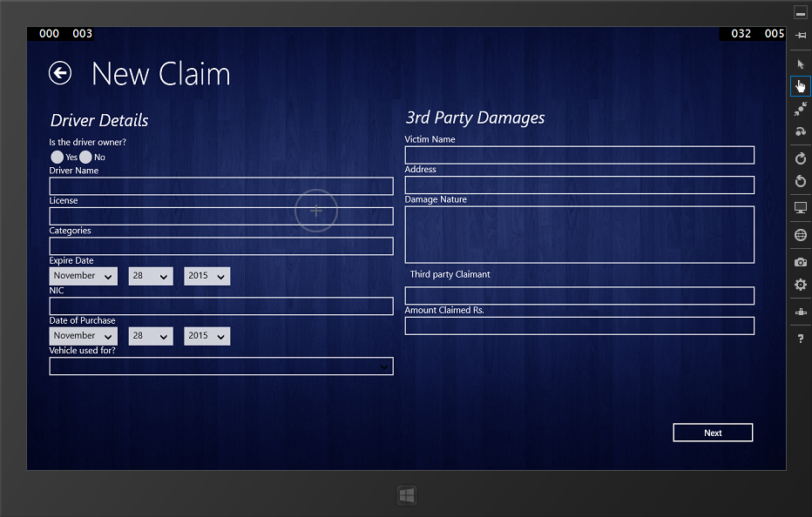

**Test Result**: Successfully received the expected message

1. On successful completion of filling second form and press Next button

**Expected Output**

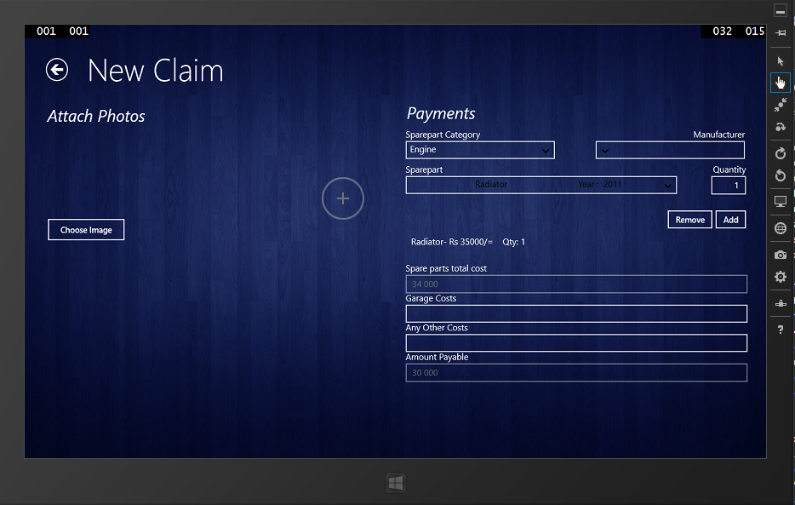

**Test Result**: Successfully received the expected message

1. On successful submit of claim

**Expected Output**

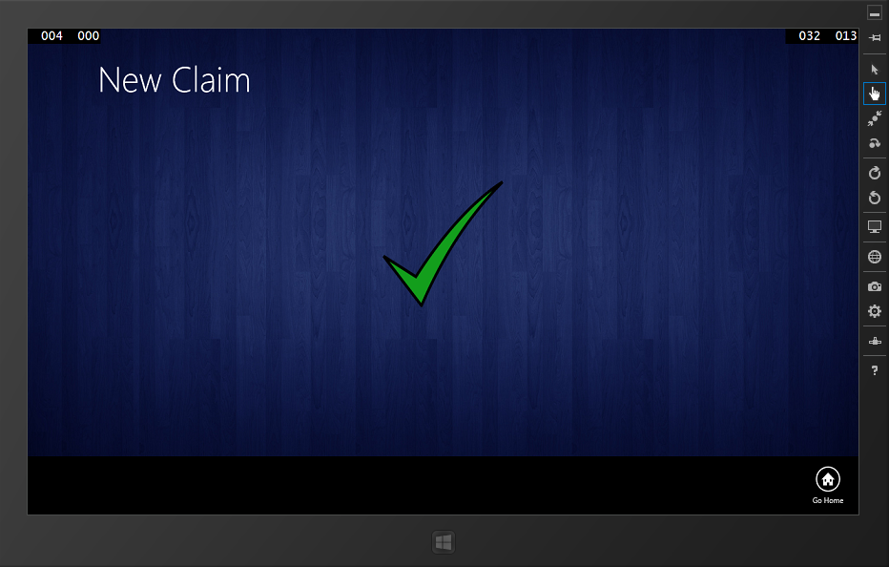

**Test Result**: Successfully received the expected message

**Test logs**

**Test Case:** Testing and validating vehicle spare part informationmodule.

**Description:** Test whether application retrieves sparepart information from the company database and the system can add /remove the damaged spare part/parts and weather it displays on screen. When each item is added, the value and details of the item should be shown in a table.

**Test data:**

1. Check whether data are retrieved

**Expected Output**

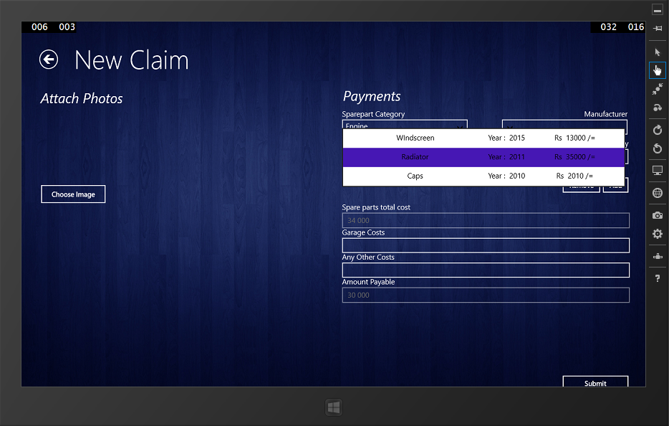

**Test Result**: Successfully received the expected output.

1. Check whether an item can be added to the claim

**Expected Output**



**Test Result**: Successfully received the expected output.

**Test logs**

**Test Case:** Testing and validating vehicle spare part informationmodule.

**Description:** Test whether application retrieves garage and tow truck services information from the company database. And also checking whether searching items by location function properly.

1. Get all garages services information

**Expected Output**

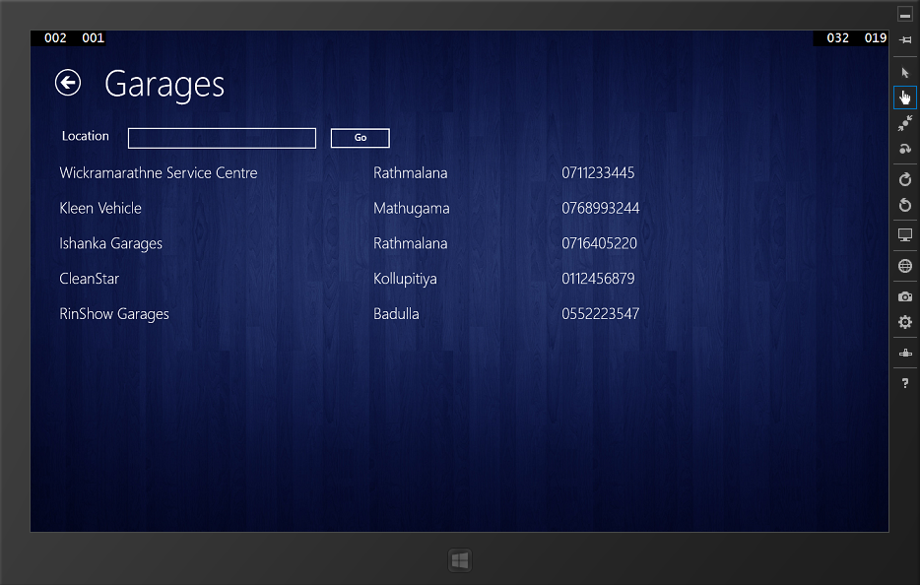

**Test Result**: Successfully received the expected output.

1. Get all tow truck services information

**Expected Output**

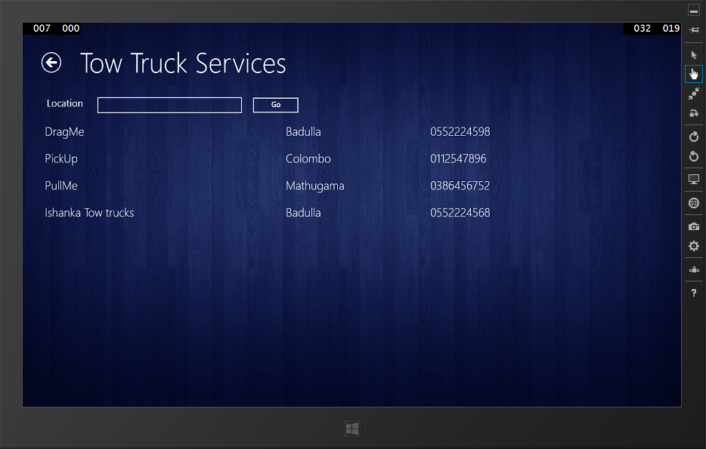

**Test Result**: Successfully received the expected output.

1. Search by location in garages services

**Expected Output**

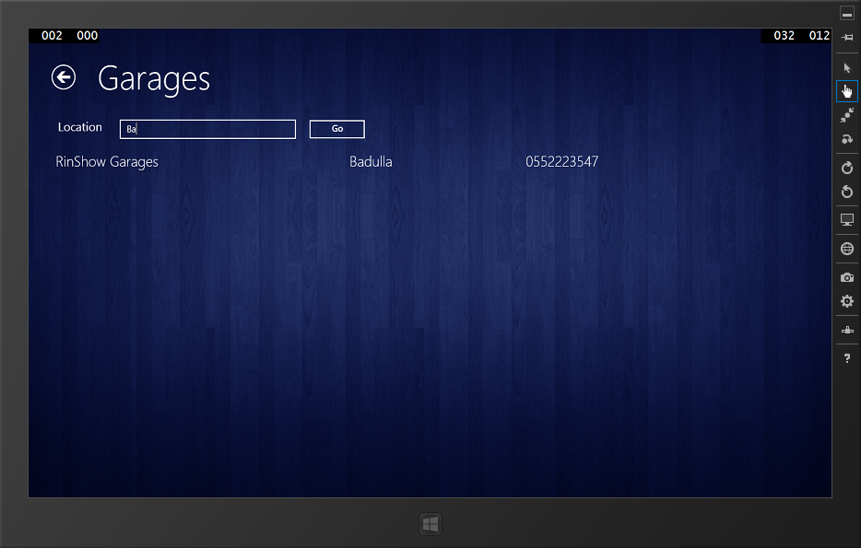

**Test Result**: Successfully received the expected output.

1. Search by location in truck services

**Expected Output**

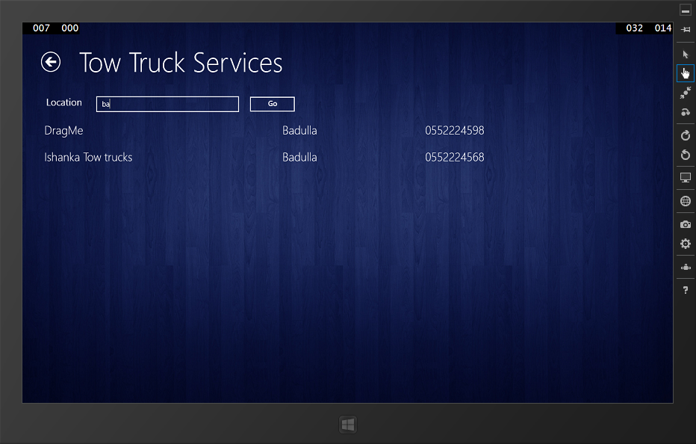

**Test Result**: Successfully received the expected output.

**Test logs**

**Test Case:** Testing and validating smartphone application.

**Description:** Test and validate claim request reporting module.

1. Testing when the client submits without policy number

**Expected Output**

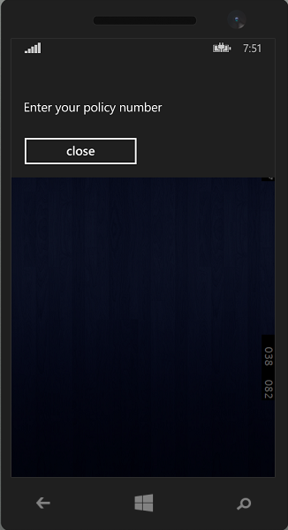

**Test Result**: Successfully received the expected output.

1. Testing when the client submits with invalid policy number

**Expected Output**

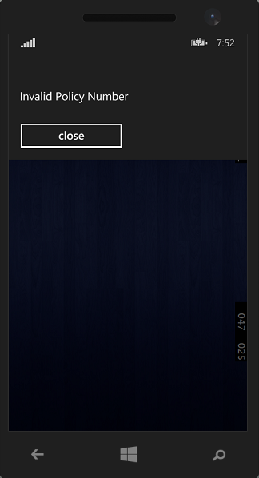

**Test Result**: Successfully received the expected output.

1. Testing when the client submits with valid policy number

**Expected Output**

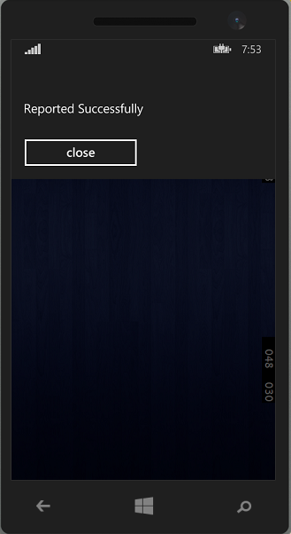

**Test Result**: Successfully received the expected output.